Student Laboratory Manual: NCI Molecular Mapping
Visualizing the "Invisible" Forces of Chemistry
1. Introduction
In this laboratory, you will move beyond 2D "stick" drawings to visualize the 3D forces that hold molecules together. Using Non-Covalent Interaction (NCI) analysis, you will create a "Map" of intermolecular forces (IMFs) to see exactly where atoms Attract or Repel each other.

2. The Visual & Graphical Key
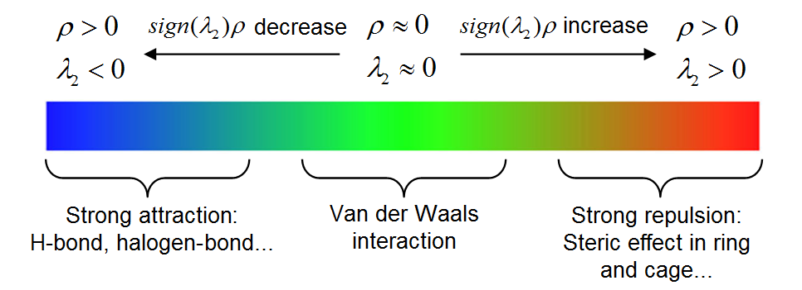
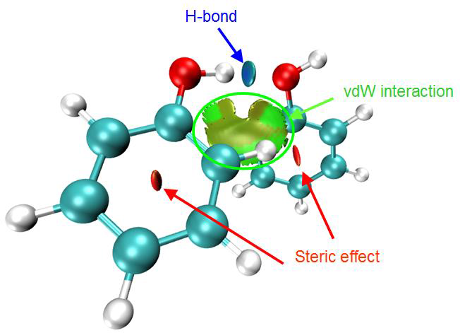
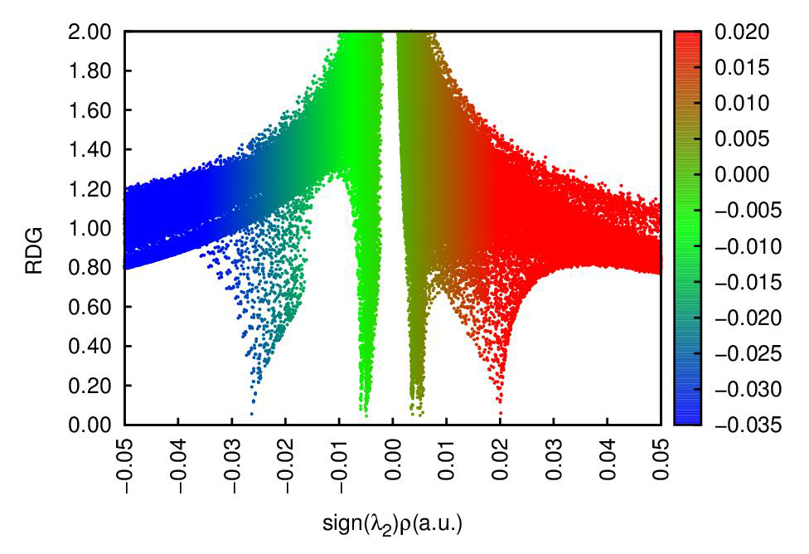
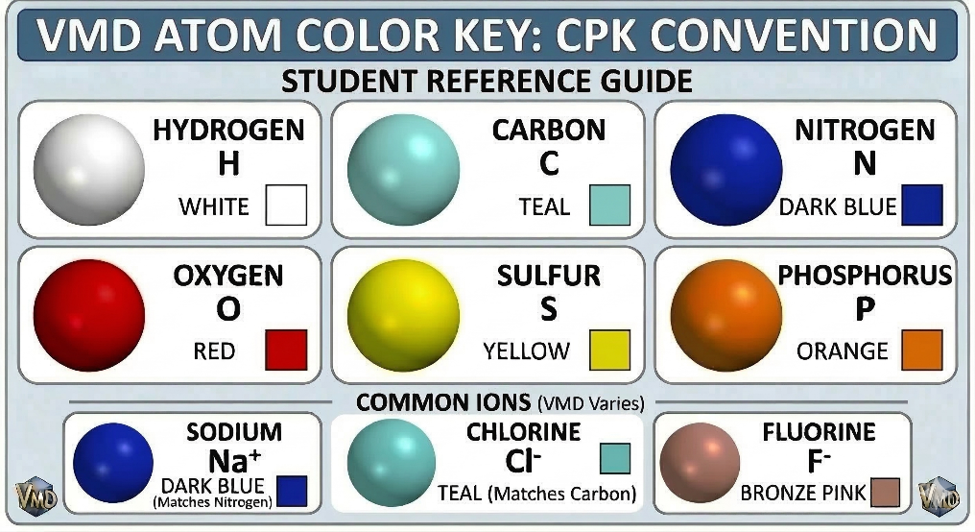
To interpret your data, you must correlate the 3D Isosurface (the "Map") with the 2D Scatter Plot (the "Spikes").
H-Bond
Steric
VdW

Understanding the 2D RDG Graph
The 2D Scatter Plot is the mathematical proof of what you see in the 3D model. Every "spike" on the graph represents a physical interaction between atoms.
1. The X-Axis: Attraction vs. Repulsion
The horizontal axis sign(λ2​)ρ (x-axis) tells you the nature of the force:
- Negative Values (Left Side): These represent Attraction. The further to the left a spike is, the "stronger" or more "concentrated" the attraction.
- Positive Values (Right Side): These represent Repulsion. This is where atoms are "pushing" against each other due to crowding.
- Near Zero: These represent very weak forces (Van der Waals) or "empty" space where atoms are barely interacting.
2. The Y-Axis: Identifying the Surface
The vertical axis (y-axis) represents the Reduced Density Gradient (RDG).
- The 0.5 Limit: In this lab, we only observe interactions below the RDG value of 0.5. This is the threshold where the 3D "isosurface" (the discs and clouds) is formed.
- The "Spike": When the graph "dips" into a sharp spike below 0.5, it means the computer has located a stable interaction. Anything above 0.5 is considered "background" and is not part of the molecular mapping you see in 3D.

3D Shape & Color | 2D Spike Position (x-axis) | Physical Meaning
Deep Blue / Cyan Disc | Far Left (Negative) | Strong Attraction (Ionic or O-H)
Green / Light Blue Disc | Center-Left (Negative) | Moderate Attraction (N-H)
Green Cloud | Near Zero (Negative) | Weak Attraction (Dipole-Dipole)
Red/Yellow Region | Right Side (Positive) | Steric Repulsion (Crowding)

3. From Lewis Structures to 3D Reality (The Theoretical Prediction)
Individual Task: Before the computers are turned on, every student must draw the Lewis structures for the 10 molecules below.
Task: Identify the δ+ and δ- regions for each inapplicable.
Hypothesis: Predict the Color (Blue, Green, or Red) and Shape (Disc, Cloud, or Ring-Center) you expect to see for the primary interaction.
System | Lewis Structure Sketch | Predicted IMF Type (H-Bond, Dipole, or Ionic) | Predicted NCI Color & Shape (Blue, Green, or Red)
Benzene
Pyridine
Water Trimer
Ammonia Trimer
Acetone- Formaldehyde
Formaldehyde- Formaldehyde
NaCl x 3
NaF x 3
2-Hydroxybenzoic Acid
2-Aminobenzoic Acid

4. Procedure: Collaborative Research Groups
Each group is responsible for a specific set of molecules. You will process your data and upload it to the Class Google Doc so that build a class-wide library.
Group 1: Benzene & Pyridine: Focus: Compare the Repulsion in the center of the pure carbon ring (Benzene) vs. the nitrogen-substituted ring (Pyridine).
Group 2: Water & Ammonia: Trimers: Focus: Blue vs. Green Attraction Discs (Electronegativity).
Group 3: Acetone & Formaldehyde: Focus: Alignment of δ+ and δ- green clouds in Dipole-Dipole systems.
Group 4: NaCl & NaF: Focus: Identifying the Strong Attraction Discs formed in ionic compounds.
Group 5: 2-Hydroxybenzoic & 2-Aminobenzoic Acids: Focus: Comparing H-bond Attraction strength in functional groups.

5. Data Processing Steps (See the supplemental instructions.)
Instructor will provide guided tours of each step
Generate Data: Run your assigned molecules in Gaussian 09W and generate the .chk file.
Step 1: Generate the Formatted Checkpoint (.fch)
Before you can make a .fch file, you need the "Formatted" version of the checkpoint file.
- Run the Job: Open your .gjf file in Gaussian 09W and click Run.
- Locate the Binary Checkpoint: Once the job finishes (Normal Termination), look in your folder for a file ending in .chk.
- Open FormChk Utility: In the main Gaussian 09W control window, go to Utilities → FormChk.
- Convert: * Input File: Select the .chk file from your lab Multiwfn_3.8_dev_bin_Win64_Jul24-master folder.
- Output File: It will automatically suggest a filename ending in .fch. Save this to your folder.
- Click OK. A black DOS-style window will flash briefly and disappear. You now have a .fch file.
Step #2: Automated Analysis: Move your .fch file into the Multiwfn_3.8_dev_bin_Win64_Jul24-master folder and run (double click) the Run_EJ_FCH script.
Step #3: Saving and Labeling: Save your images as an .png file with labels for both the 3D and 2D plots. (Instructor will provide a detailed description of this process.)
Step #4: Sharing: Upload your labeled 3D Surface and your 2D RDG Graph to the Class Google Doc.

6. Observation Guide: The "Great Comparison" (Validating Your Predictions)
Collaborative Task: Once the Class Google Doc is populated with 3D images and 2D graphs from all groups, complete the following analysis.
6(a). The Electronegativity Reality Check
Look at the Water Trimer vs. the Ammonia Trimer.
- Prediction: Did you think they would be the same strength?

- Observation: Look at the Google Doc. Is the Oxygen-based disc "Bluer" and further left on the x-axis than the Nitrogen-based one?

- Conclusion: How does the NCI map visualize the 0.5 difference in electronegativity between O and N?

6(b). The Ionic "Disc" Surprise
Look at NaCl and NaF.
- Prediction: Did you expect a "cloud" or a "disc"?

- Observation: Notice the Intense Blue Disc.

- Conclusion: Compare the NaF disc to the NaCl disc. Which halogen attracts more strongly? How does the 2D spike confirm this?

6(c). The "Empty" Space Mystery
Look at Benzene and Pyridine.
- Prediction: Did you draw anything in the center of the ring?

- Observation: Identify the Red region in the center.

- Conclusion: Does the presence of Nitrogen in Pyridine change the "crowding" (Repulsion) compared to the all-carbon Benzene?

6(d). Geometry: Discs vs. Clouds
Compare Acetone-Formaldehyde (Dipole) to Water Trimer (H-Bond).
Observation: Why does the H-bond form a focused Disc while the Dipole-Dipole forms a diffuse Green Cloud?
Conclusion: Which interaction requires more "perfect" alignment to be stable?

7. Final Section: Learning Impact & Reflection
7(a). Learning Impact (Anonymous Likert Scale)
Rate your agreement with the following statements from 1 (Strongly Disagree) to 5 (Strongly Agree).
- The red color inside the ring (Benzene/Pyridine) helped me visualize "steric hindrance" (Repulsion) better than a textbook definition.
1 — 2 — 3 — 4 — 5
- I can see that Hydrogen bonds and Ionic interactions are more "pointed" (forming focused Attraction Discs) than Dipole-Dipole forces (which appear as diffuse Clouds).
1 — 2 — 3 — 4 — 5
- Comparing Ionic Attraction (NaCl vs. NaF) helped me see how electronegativity affects the "color" and intensity of an interaction.
1 — 2 — 3 — 4 — 5
- Seeing the 3D alignment of the Dipole-Dipole interactions (Acetone/Formaldehyde) helped me better visualize how molecules position themselves in space.
1 — 2 — 3 — 4 — 5

7(b). Final Synthesis (Short Answer)
To be completed after reviewing the full Class Google Doc.
- The Magnitude of Attraction: Look at the 2D RDG plots for Water Trimer (Oxygen) and Ammonia Trimer (Nitrogen). Which one has the spike further to the left (more negative)? How does this numerical data the value of sign(λ2​)ρ along the x-axis support your "Blue vs. Green" visual observation of the Attraction Discs?

- Correcting the Model: Identify one molecule where your predicted Lewis structure was different from the NCI Map. What did the computational model show you that the 2D drawing could not? (e.g., unexpected repulsion, a different attraction shape, or a change in intensity).

- The "Disc" vs. The "Stick": In your own words, why is it useful for a chemist to see the volume (the disc or cloud) of an attraction rather than just drawing a dashed line between atoms?

